| **S.No** | **Javascript** |  | **NodeJS** |
| --- | --- | --- | --- |
| 1. | Javascript is a programming language that is used for writing scripts on the website. |  | NodeJS is a Javascript runtime environment. |
| 2. | Javascript can only be run in the browsers. |  | We can run Javascript outside the browser with the help of NodeJS. |
| 3. | It is basically used on the client-side. |  | It is mostly used on the server-side. |
|  | Javascript can run in any browser engine as like JS core in safari and Spidermonkey in Firefox. |  | V8 is the Javascript engine inside of node.js that parses and runs Javascript. |
| 4. |  |  |  |
|  | Javascript is used in frontend development. |  | |  | | --- | | Nodejs is used in server-side development. | |  | |
| 5. |  |  |  |
| 6. | Javascript is used in frontend development. |  | Nodejs is used in server-side development. |
|  |  | |  |

1. **List 5 difference between Browser JS(console) v Nodejs**
2. **watch & summary 5 points –**

[**https://www.youtube.com/watch?v=SmE4OwHztCc&ab_channel=JSConf**](https://www.youtube.com/watch?v=SmE4OwHztCc&ab_channel=JSConf)

How does the browser actually render a website | JSConf EU 2015

**FRONT END SIDE OF THINGS:**

* **High level view**
* **In-depth view**
* **Performance insights**

**High level flow:**

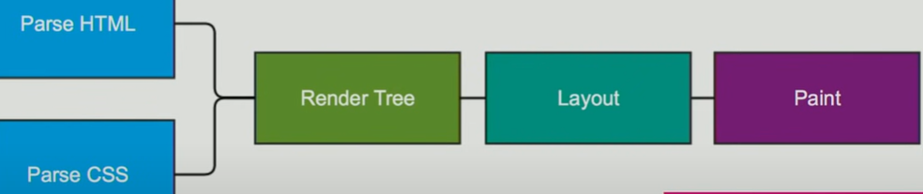

**Tokeniser:**

**Start tag**

**< div >**

**Tag open tag name tag close**

**End tag**

**< / div >**

**Close tag open tag name tag close**

**<script>,<link>&<style>**

* Network latency
* Link&style could halt js execution

**Performance insights:**

**<script/>** at the bottom

* Parse uninterrupted
* Faster to render
* Defer &async attribute.

**DOM&CSSOM:**

Combination the two object model ,style resolution.

**Multiple trees:**

* Render objects
* Render styles
* Render layers

**Not in the render tree:**

* Non-visual elements head,script,title..
* Nodes hidden via display:none;

**Painting set up:**

* Will take the layout render trees.
* Creates layers
* Increment process

And finally composites the textures into a final image to render into the screen.

1. **To read –**

**https://stackoverflow.com/questions/5641997/is-it-necessary-to-write-head-body-and-html-tags**

## Definition and Usage

The <head> element is a container for metadata (data about data) and is placed between the <html> tag and the <body> tag.

Metadata is data about the HTML document. Metadata is not displayed.

Metadata typically define the document title, character set, styles, scripts, and other meta information.

The following elements can go inside the <head> element:

* [<title>](https://www.w3schools.com/tags/tag_title.asp) (required in every HTML document)
* [<style>](https://www.w3schools.com/tags/tag_style.asp)
* [<base>](https://www.w3schools.com/tags/tag_base.asp)
* [<link>](https://www.w3schools.com/tags/tag_link.asp)
* [<meta>](https://www.w3schools.com/tags/tag_meta.asp)
* [<script>](https://www.w3schools.com/tags/tag_script.asp)
* [<noscript>](https://www.w3schools.com/tags/tag_noscript.asp)

<!DOCTYPE html>  
<html lang="en">  
<head>  
  <title>Title of the document</title>  
</head>  
<body>  
  
<h1>This is a heading</h1>  
<p>This is a paragraph.</p>  
  
</body>  
</html>

**4. Execute the below code and write your description in txt file**

**a. typeof(1)**

code:console.log(typeof(1));

**ans:** **number**

**b. typeof(1.1)**

console.log(typeof(1.1));

**ans:** **number**

**c. typeof('1.1')**

console.log(typeof(‘1.1’));

**ans: string**

**d. typeof(true)**

console.log(typeof(true));

**ans: boolean**

**e. typeof(null)**

console.log(typeof(null));

**ans:object**

**f. typeof(undefined)**

console.log(typeof(undefined));

**ans: undefined**

**g. typeof([])**

console.log(typeof([]));

**ans: object**

**h. typeof({})**

console.log(typeof({}));

**ans: object**

**i. typeof(NaN)**

console.log(typeof({}));

**ans: undefined**

**5.Read what is prototype**

**A prototype is an early sample, model or release of a product created to test a concept or process.** Typically, a prototype is used to evaluate a new design to improve the accuracy of analysts and system users. It is the step between the formalization and the evaluation of an idea.

Prototypes **are a crucial part of the design process** and a practice used in all design disciplines. **From architects, engineers, industrial designers and even service designers,** they make their prototypes to test their designs before investing in their mass production.

## There are several types of prototypes;

* **Low fidelity prototypes**
* **Media fidelity prototypes**
* **The hi-fi prototypes**